**Báo Cáo login, logout dùng spring security**

1. **Cấu hình security trong file pom.xml**

Thêm vào

<!-- Spring Security -->

<dependency>

<groupId>org.springframework.security</groupId>

<artifactId>spring-security-core</artifactId>

<version>3.1.3.RELEASE</version>

</dependency>

<dependency>

<groupId>org.springframework.security</groupId>

<artifactId>spring-security-web</artifactId>

<version>3.1.3.RELEASE</version>

</dependency>

<dependency>

<groupId>org.springframework.security</groupId>

<artifactId>spring-security-config</artifactId>

<version>3.1.3.RELEASE</version>

</dependency>

<dependency>

<groupId>org.springframework.security</groupId>

<artifactId>spring-security-taglibs</artifactId>

<version>3.1.3.RELEASE</version>

</dependency>

<!-- Mysql -->

<dependency>

<groupId>mysql</groupId>

<artifactId>mysql-connector-java</artifactId>

<version>5.1.5</version>

</dependency>

1. **Tạo 2 file xml là: security-context.xml và spring- database.xml**

**Nội dung file security-context.xml**

<beans:beans xmlns=*"http://www.springframework.org/schema/security"*

xmlns:beans=*"http://www.springframework.org/schema/beans"*

xmlns:xsi=*"http://www.w3.org/2001/XMLSchema-instance"*

xsi:schemaLocation=*"http://www.springframework.org/schema/beans*

*http://www.springframework.org/schema/beans/spring-beans-3.0.xsd*

*http://www.springframework.org/schema/security*

*http://www.springframework.org/schema/security/spring-security-3.1.xsd"*>

<http pattern=*"/"* security=*"none"*/>

<http use-expressions=*"true"*>

<intercept-url pattern=*"/**"* access=*"isAuthenticated()"*/>

<form-login login-page=*"/"* default-target-url=*"/login"* authentication-failure-url=*"/login"*/>

<logout logout-url=*"/logout"* logout-success-url=*"/"*/>

</http>

<authentication-manager>

<authentication-provider>

<jdbc-user-service data-source-ref=*"dataSource"*

users-by-username-query=

*"select taikhoan, matkhau, enabled from taikhoan where taikhoan=?"*

authorities-by-username-query=

*"select taikhoan, quyen from quyen where taikhoan=? "* />

</authentication-provider>

</authentication-manager>

</beans:beans>

Nội dung file spring-database.xml

<beans xmlns=*"http://www.springframework.org/schema/beans"*

xmlns:xsi=*"http://www.w3.org/2001/XMLSchema-instance"*

xsi:schemaLocation=*"http://www.springframework.org/schema/beans*

*http://www.springframework.org/schema/beans/spring-beans-3.0.xsd"*>

<bean id=*"dataSource"*

class=*"org.springframework.jdbc.datasource.DriverManagerDataSource"*>

<property name=*"driverClassName"* value=*"com.mysql.jdbc.Driver"* />

<property name=*"url"* value=*"jdbc:mysql://192.168.1.10:3306/qlhocsinh"* />

<property name=*"username"* value=*"root"* />

<property name=*"password"* value=*"worklife@2014"* />

</bean>

</beans>

1. **Tạo database**

Bảng tài khoản:

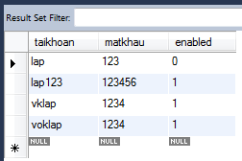

Bảng quyền:

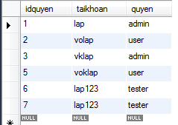

1. **Cấu hình file web.xml thêm vào:**

<!-- Spring security -->

<listener>

<listener-class> org.springframework.web.context.ContextLoaderListener

</listener-class>

</listener>

<context-param>

<param-name>contextConfigLocation</param-name>

<param-value>

/WEB-INF/spring/appServlet/security-context.xml

/WEB-INF/spring/appServlet/spring-database.xml

</param-value>

</context-param>

<filter>

<filter-name>springSecurityFilterChain</filter-name>

<filter-class>

org.springframework.web.filter.DelegatingFilterProxy

</filter-class>

</filter>

<filter-mapping>

<filter-name>springSecurityFilterChain</filter-name>

<url-pattern>/*</url-pattern>

</filter-mapping>

1. **Tạo file login.jsp**

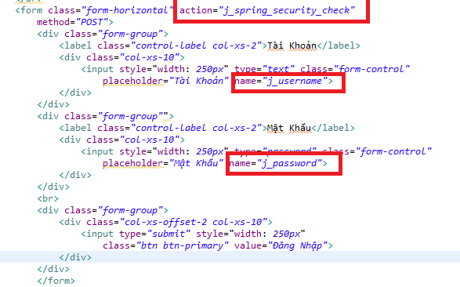

1. **Màn hình login**

Nếu Đăng Nhập sai:

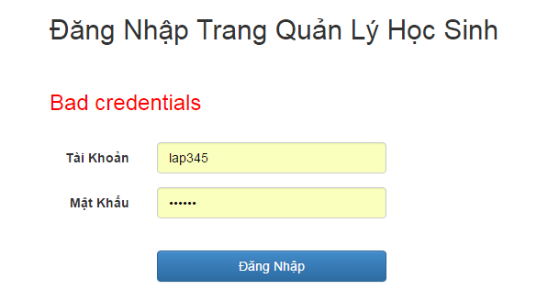

Nếu có tài khoảng và chưa được duyệt

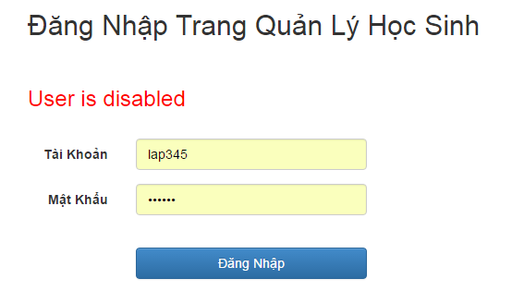

Có tài khoản và được duyệt thì sẽ login vào được trang Danh Sách học sinh.

